MED D - Dual Demo/MMP/DSNP - Single Transaction Coordination of Benefits (STCOB) Tips and Reminders

Overview
How to Identify a Dual Demo/MMP/DSNIP Plan in PeopleSafe
Tips and Reminders
Active Clients with Dual Demo/MMP/DSNIP Plans
Log Activity
Resolution Time
Related Documents

Description: This job aid assists with Dual Demo/MMP/DSNP STCOB Calls.

Overview
MED D CCRs should utilize PeopleSafe, CIF, and this job aid to determine if the beneficiary is a Dual Demo (Dual Demonstration)/MMP (Medicare-Medicaid Plan)/DSNP (Dual Special Needs Plan).

A Dual Demo Plan is a type of health insurance plan for people who have both Medicare and Medicaid, also referred to as dual-eligible. You may also see these plans referred to as MMP (Medicare/Medicaid Plan) or DSNP (Dual Special Needs Plan).
- A Medicare Advantage MMP is a private health plan that provides coordinated Medicare and Medicaid benefits for dually eligible individuals. MMPs simplify the processes for dual eligible individuals to access the care they are entitled to under Medicare and Medicaid programs. This includes providing beneficiaries with a seamless enrollment and disenrollment process and access to high-quality integrated healthcare.
- MMPs differ from SNPs in that they are a totally aligned product designed to further strengthen the coordination of Medicare and Medicaid Services. An MMP is an alignment initiative in which Medicare and Medicaid benefits are offered as a single plan in a three-way contract between CMS, the state Medicaid agency (SMA), and the health plan; a D-SNP model is when a health plan holds a contract with Medicare and then a separate contract with the SMA to provide Medicaid benefits at varying levels of integration.

Dual Demo Plan Characteristics
- Medicare D is the primary benefit, Medicaid is the secondary benefit and can be managed by CVS Caremark or another PBM (Prescription Benefit Manager).
- Dual members will pay a little-to-no copay, for covered medications.
- Dual Demo Plans will never have a deductible.
- Medications that are excluded by Medicare could be covered under the Medicaid portion of the plan.
- STCOB beneficiaries do not need to take any action to have their benefits coordinated. This is set up on their behalf by their plan.
- STCOB beneficiaries who have Medicare D and Medicaid coverage through CVS Caremark, will receive only one ID card.

There are currently 9 participating states:
- California
- Illinois
- Massachusetts
- Michigan
- New York
- Ohio
- Rhode Island
- South Carolina
- Texas

Each of these states has begun either voluntary or passive enrollment of duals into fully integrated plans providing both Medicaid and Medicare benefits (“Medicare-Medicaid Plans,” or “MMPs”) under three-way contracts between the state, the Centers for Medicare & Medicaid Services (CMS), and the MMP.

Top of the Document

How to Identify a Dual Demo/MMP/DSNIP Plan in PeopleSafe

MED D & Medicaid Dual Demo STCOB | 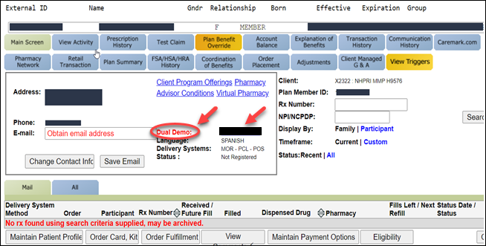  - Review the Supplemental Payer section of the Main screen.  - If there is a Plan Beneficiary ID with a hyperlink, then the beneficiary has STCOB.  - This Plan Beneficiary ID is the beneficiary secondary Plan Beneficiary ID.  - The hyperlink will open the alternate account, allowing you to switch between the primary and secondary accounts.  - When quoting information such as drug coverage and pricing, order status, and refills, CCRs must ensure they are working within the beneficiary’s primary Medicare D account.  Note: When you click the Supplemental Payer link, you will be logged out of the primary account and will have to log the call before moving to the secondary Medicaid account. The only reason to access the secondary account is to enter an override. Approved overrides should be entered in the Primary and Secondary account. Follow standard Plan Benefit Override work instructions: MED D - Early Refills/Plan Benefit Overrides (PBO) - CCR.

Top of the Document

Tips and Reminders
It is very important to check the High Priority Comments and the CIF on every Dual Demo/MMP/DSNIP call. Do NOT rely on PeopleSafe alone. Before quoting cost/coverage to members, double check all other resources to ensure there isn’t a custom process that should be followed.

The following will assist the CCR when addressing Dual Demo/MMP/DSNP issues:

From the Details button on the Test Claim screen, the CCR can: | - View the amount the secondary plan paid on the claim, cost displayed on the primary plan screen shot below may not be accurate.  - View rejection reasons that occurred on the secondary account  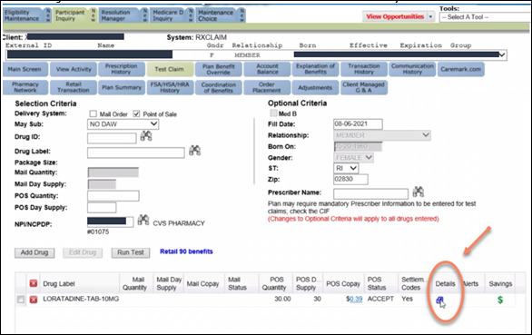  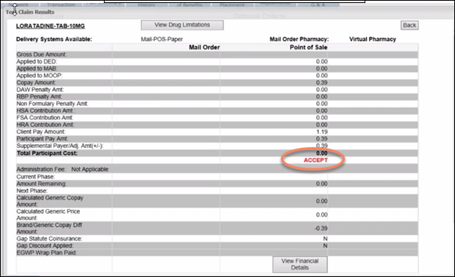  If you click on the Settlement Codes, you may see that the claim has reject messages associated.  Note: These are not necessarily associated with the secondary coverage. Refer to the screen above to confirm coverage/copay details on the secondary.  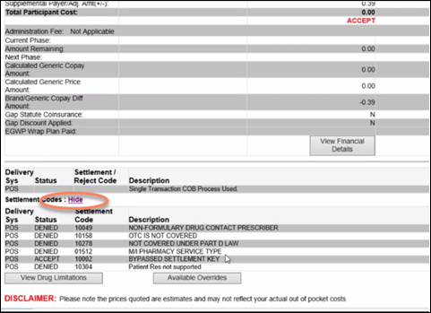
Dual Demo/MMP/DSNP Accounts: Explaining to Beneficiaries | The following are tips on how to respond to inquiries from beneficiaries on common Dual Demo/MMP/DSNP account scenarios:  Scenario 1: The drug wasn’t covered on primary (Med D) but was covered on the Secondary benefit.  - If a drug is not covered on the primary it might be covered on the Secondary benefit. To quote an accurate copay, you must click on the price link or Details button on the Test Claim screen.  - An example of drug category that this scenario applies to is OTC Drugs (other drug categories may apply).  Scenario 2: Drug requires a PA or has Quantity Limits  - To determine if a drug requires PA or has a Quantity Limit:  - Run a test claim and click on Details, then View Financial Details, and then click on the Details button in PeopleSafe to find the beneficiary’s copay  - If a drug rejects on the Primary Med D, it may still pay on the Secondary Benefit.  - If the drug has a PA or quantity limit that is Not covered on the Secondary benefit, then a Coverage Determination can be filed. Refer to MED D - Coverage Determinations and Redeterminations (Appeals)  - Review the CIF to determine who handles the CD&A process.  Note: A transition fill is not available for a drug that is rejected for B vs. D determination. The coverage determination must be done in order to determine how the plan will pay for the drug. Refer to MED D - Coverage Determinations and Redeterminations (Appeals).  - Review the CIF to identify who handles the CD&A process.

Top of the Document

Active Clients with Dual Demo/MMP/DSNIP Plans

Client Name & Carrier | Carrier(s) | Type of Plan | Plan Highlights
Neighborhood Health Plan of Rhode Island (NHPRI) | x2322, x6441 | Dual Demo/MMP | Secondary Medicaid coverage covers OTC medications not covered under Medicare.
Devoted Health | x8704 x6203 | DSNP | Carrier x6203 is a new DSNP plan effective 01/01/2021. Not all members under carrier x8704 have the STCOB secondary plan.
BSC | x33MH | MMP | Also known as the Cal-Medi Connect (CMC) plan.
Healthfirst | x1110, x1117 | DSNP | Healthfirst Compete Care members have Medicare primary coverage and Medicaid secondary coverage (x1117). These members also have Medicaid Fee-for-service (FFS) through the state, there are six drugs that they could possibly receive coverage for, directly from the state, through their FFS benefit, using their Medicaid FFS card. Please review the CIF for drug coverage and copays on members in this plan, the coverage can include medications not covered under Part D law.
Molina | X5062, x0865, x0862, x5008, x5058, x0864, x5009, x0863, x5060, x0866, x5005, x0861 | Dual Demo | Plan utilizes a single transaction COB process. For drugs not covered under Med D, the claim attempts to adjudicate “automatically” to the Medicaid carrier.

Top of the Document

Log Activity
1309 - Coordination of Benefits

Top of the Document

Resolution Time
Information = Immediate

Top of the Document

Related Documents
Abbreviations/Definitions: Abbreviations / Definitions

Top of the Document
Not to Be Reproduced or Disclosed to Others without Prior Written Approval
ELECTRONIC DATA = OFFICIAL VERSION – PAPER COPY = INFORMATIONAL ONLY

